USB Mouse

Comfortable, accurate optical tracking

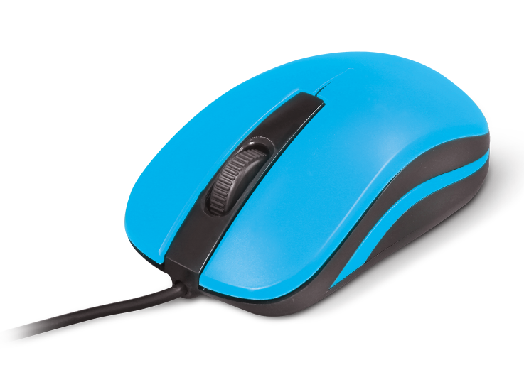

Descrption:
Plug n' Play USB for instant useability

Generous length USB cable cordage for instant connection to your PC, Mac, Android or any other device with a USB port
Comfortable, natural control with less strain

Carefully designed for both left and right-hand users with a more natural grip. Full, three-button technology with central scroll-wheel for easy navigation
HD optical tracking
Enhanced 1000dpi LED tracking gives superior on screen control for both office and gaming applications. Works on almost any surface too
Control all your devices

Ideal for WindowsTM, MacTM, LinuxTM computers with any avaliable USB port. Also control your AndroidTM tablet or other device with any compatible USB port

Features:

Comfortable, natural control

Optical tracking - ideal for all surfaces

Performance LED optics - for more accurate tracking

3-Button plus scroll-wheel control for all applications

Plug n' Play - driverless, works with all OS!

Specifications
- material :ABS material
- Port：USB
- Cable: 1.5M lenght
- DPI Button：1000 DPI adjustable
- Buttons：Left, Right, Wheel
- Wheel：1 Scrolling Wheel
- Certificate: CE FCC ROHS
- Operating Temperature:0℃ to +45℃
- Operating Humidity:10%0 to 85 % RH
- Storage Temperature : -10℃ to +55℃
- Storage Humidity: 5% to 90 % RH

Product Code:
Part number: M200-BLK Barcode: 8400800033710
Part number: M200-BLU Barcode: 8400800033727
Part number: M200-RED Barcode: 8400800033734
Size: 10X5X3.2 cm
Weight: 0.245 kg

